**CSCI 1411: Fundamentals of Computing**

**Lab 3**

**Due Date: February 09, 2022**

**Name: Abhinav Shrestha**

**Goals:**

* Use of variables of type int, double, float, char, string
* Use of operators +, -, /, *
* Understand integer and float operations

**Development Environment:** Hackerrank.com**,** IDLE

**Deliverables:**

1. This lab with 3 screen shots.
2. Your code for Part III

How to take a **screen shot**:

* For a Windows 10: Use Snipping Tool to copy and CTRL + V paste screen shot.
* For Mac: Shift + Command + 4 to copy and CTRL + V to paste screen shot.

**Part I – Hello World (5 points)**

* A great (and fun) way to practice Python is to challenge yourself to practice and competitions. There is a web site that allows you to do exactly that.
* Remember the ROCkET Methodology
  + **R**ead the entire problem, taking notes and underlining important areas
  + **O**utline the tasks in plain English with enough detail to write code
  + **C(k)**ode small portions at a time
  + **E**valuate each small portion of code. Ensure it compiles AND does what it is supposed to
  + **T**est the entire program. Ensure it compiles AND does everything listed in the outline
* Go to [www.hackerrank.com](http://www.hackerrank.com), and set up a free account.
* Click on the Python 3 tile.
* Your first challenge should be to test out the hackerrank.com environment. You will type in following right after the #Hint statement:
  + return a+b
* Click the RUN CODE
* This should get you to the dashboard. Scroll down and click on the Python link

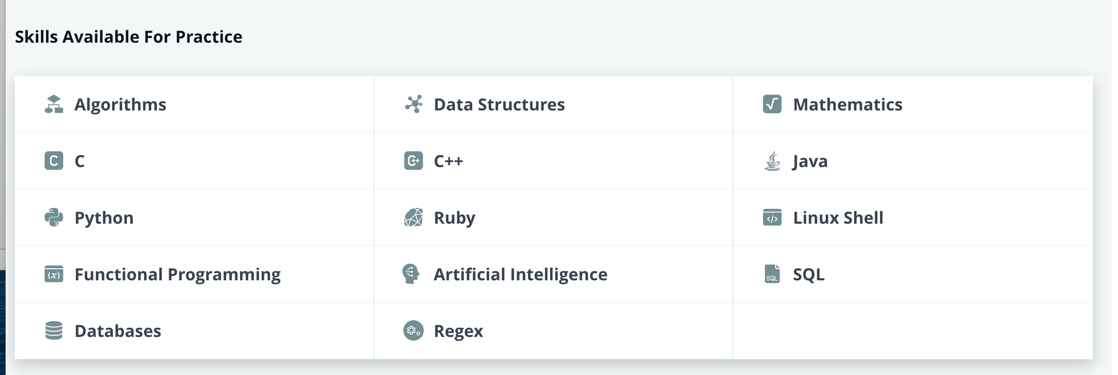

* Click the Continue Practice button.
* The very first challenge should be Hello World

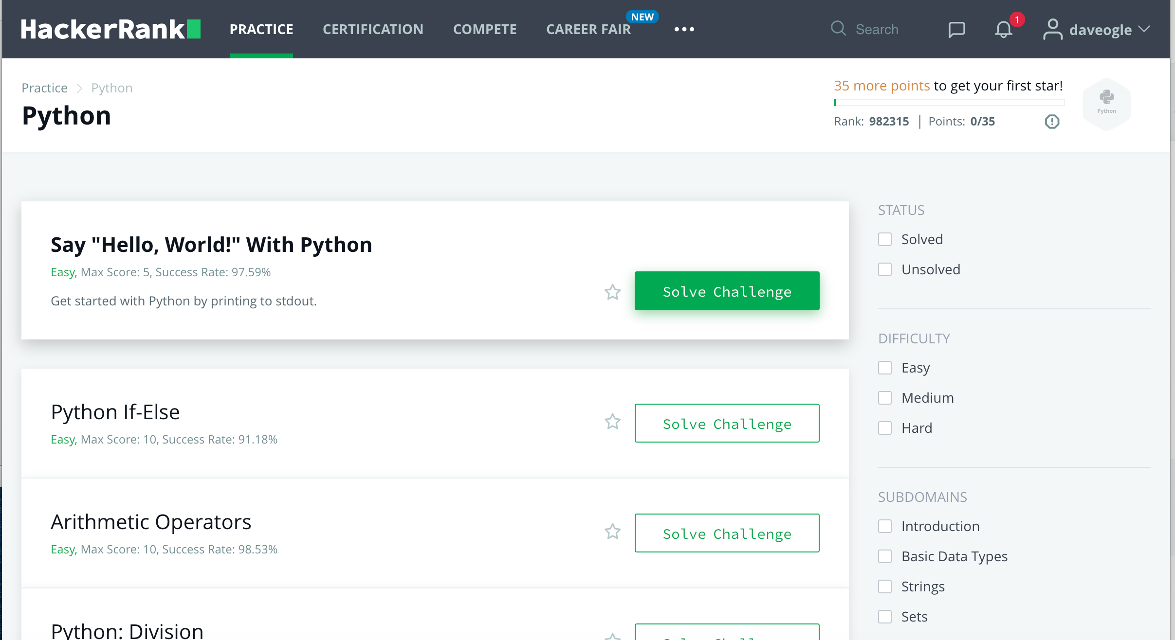

* Click on Solve Challenge next to Hello World and solve the problem!
* If there are any errors, then it will tell you where the error. If you run into issues, talk to your instructor who will give you some hints.
* After you get success message, go to the submissions tab and take a **screen shot** showing that your lab was accepted and post it here.

**Part II – Arithmetic Operators (10 points)**

* Complete the Arithmetic Operators challenge on hackerrank.com.
* Again, read the entire problem
* Fill in the code.
* Submit
* If you don’t get success message, work with your lab partner to see if you can get “Congratulations” message. After a “reasonable” amount of troubleshooting, ask your instructor for some hints.
* After you get success message, go to the submissions tab and take a **screen shot** showing that your lab was accepted. Post that screenshot here

**Part III – Float versus Integer data types (10 points)**

In this part of the lab, we will be writing some code that demonstrates the difference between floating point division and integer division.

Problem statement:

* You have a **box** that has a length and width in inches. These lengths and widths are not restricted to be in whole numbers (e.g., the length could be 11.2 inches)
* You want to put trim around the box, but the local HW store only sells trim in 12” segments.
* A 12” segment of trim costs $1.88.

Create a program that does the following things:

* Ask the user the length, in inches, of the box
* Ask the user the width, in inches, of the box
* Calculate the perimeter of the box and prints that out (recall perimeter = 2*L + 2*W)
* Calculate the number of segments needed to trim the box (go around the perimeter)
  + HINT: calculate 2 versions of this, one float, one int
  + Print the int version of number of segments
* Calculates the cost of the trim (HINT: use the int version of the number of segments) and print that out
* Calculate the amount of $$ you lost because you could not buy the trim in increments other than 12” segments (HINT: you will need to use the float number of segments and the int number of segments to calculate loss) and prints that out

The output should look something like this:

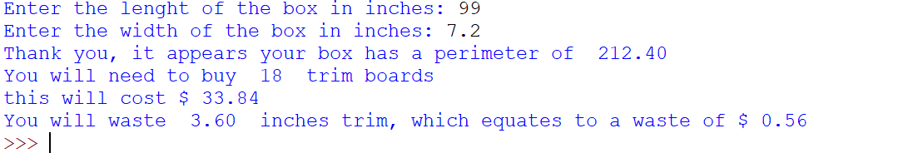

* Capture a **screenshot** of your output and paste it here

* Submit your code on Canvas